/\*

\* Qtr: Autumn 2015

\* Class: CSC212

\* Professor: Dr. Julian Achim

\* Programmer: Odiscious Dozier

\* Date: 11/25/2015

\*

\* class: JPanelDemo

\* extends: JFrame

\* implements: ActionListener

\*

\* Super class: JFrame

\* Implementing class: ActionListener

\*

\* Use of - dialog boxes, text boxes, labels, and buttons.

\*

\* Assumptions:

\* 1. Students and exams must be of equal amounts

\* 2. Since there is no student object to encapsulate student

\* data, students are structured from 1 - n; scores are

\* respective.

\* 3. There is a check for correct input, but program just cycles

\* Integers are expected

\* 4. Two ways to exit program - E/e typed into a text box or

\* clicking 'X' on the right corner of the Panel window

\* 5. If no grades are entered, assume 'F'

\* 6. If grades < 0, assume 'F'

\* Expected behavior: Insert requested data in the three text boxes,

\* click the button, and review results in a different window.

\*/

• Ask number of students.

• The number of exams we have this semester.

• Based on students' score, determine the kind of letter grade they should get display result.

These instructions are very vague and will result in varied programs. I built this solution with an as stated understanding. The program will ask for the number of students and the number of exams we have this semester. Then, the expectation is that the user will input all the grades, one grade for each student (on the same input box), and then calculate the letter grades based on those grades.

This is a classic case where questions would need to be answered and clarification need to be conducted. Taking what we know about the classroom…. There are ‘n’ number of students taking ‘x’ number of exams. Once all the students have completed all of their exams, we can then determine their letter grade. But, is this true for all classrooms and is this true for what our particular user wants? Only through participation and validation with our product owner can we be confident that the work that we’re doing truly satisfies their needs.

SCREEN SHOTS

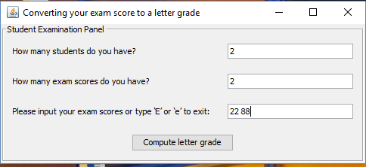

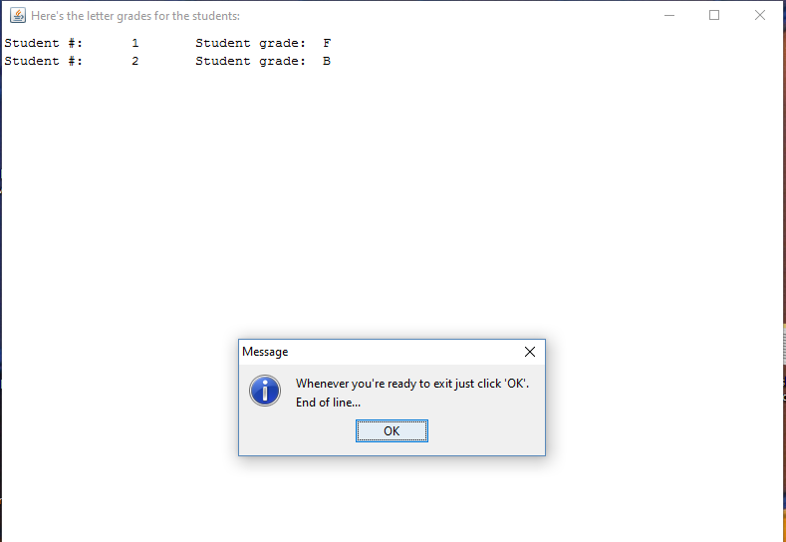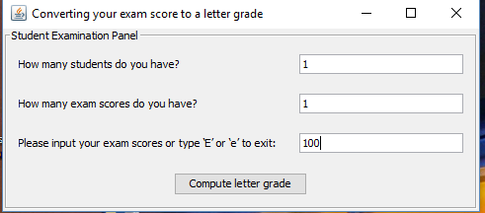

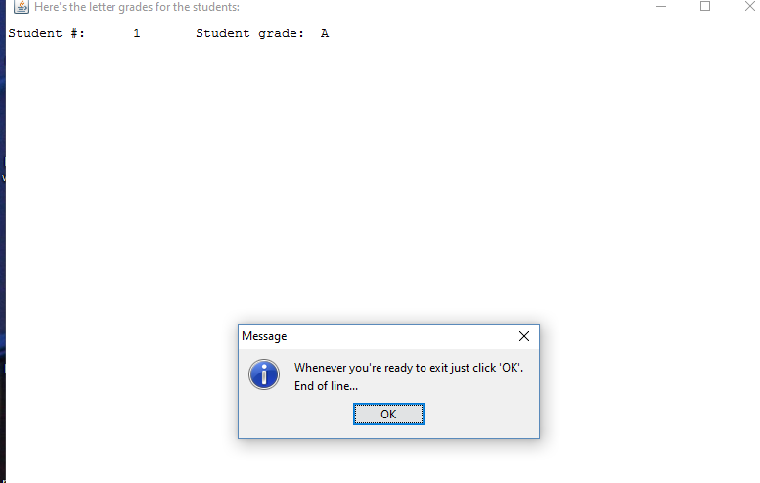

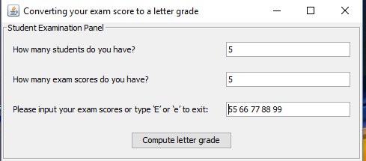

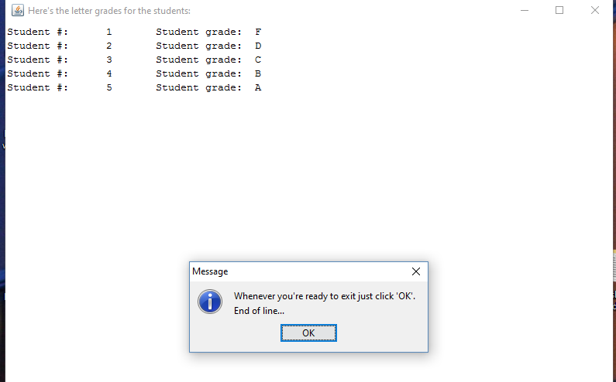

ERROR HANDLING

